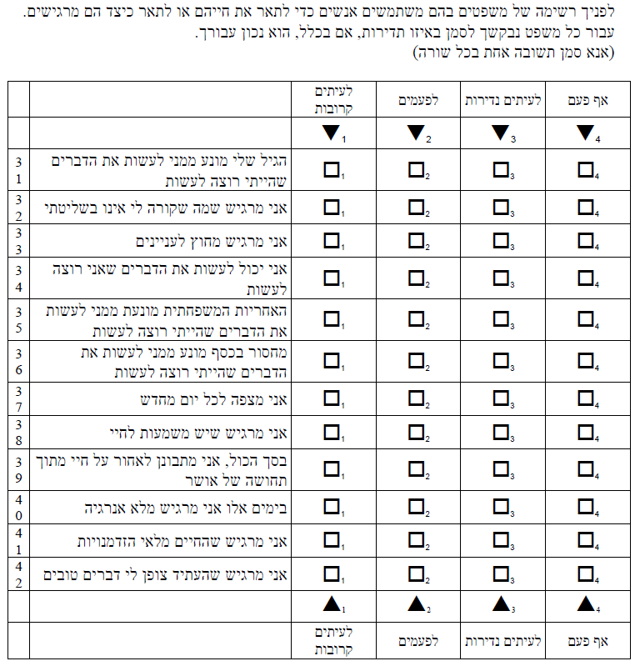

Source: Survey of Health, Ageing and Retirement in Europe. http://www.share-project.org/

